**LAPTOP REQUEST CATALOG ITEM**

# **Team Information**

**NM_ID:**D4D3C5A6DD099D583CD4A6C479CCC07F

**Team ID**: NM2025TMID15946

Team Size: 4

**Team Leader:** S PRIYA DHARSHINI

**Team Members:**  
1. LATHIKA SRI K  
2. MONISHA C  
3. PHILOMENA SRI S J

**Problem Statement**

# In many organizations, employees face delays and manual dependencies when requesting laptops due to the absence of a structured and automated process. Traditional request handling methods often involve email follow-ups, paperwork, and multiple approvals, which lead to inefficiencies, lack of transparency, and difficulty in tracking requests. This results in delayed employee onboarding, poor utilization of IT resources, and reduced productivity.

# **Objective**

The main objective of this project is to design and implement a user-friendly Laptop Request Catalog Item that automates the entire laptop request and fulfillment process. This solution aims to minimize manual effort, eliminate delays, and provide transparency at every stage of the request lifecycle. It will allow employees to select laptop models based on predefined options, capture required details, and track real-time request status. At the same time, the system will streamline approval workflows, improve IT asset tracking, and ensure efficient allocation of resources.

**Skills:**

* Problem-Solving and Logical Thinking
* Project Documentation and Presentation
* Time Management and Task Prioritization
* Collaboration and Teamwork

**STEPS TO COMPLETE THE PROJECT:**

**Create Local Update Set**

1. Open service now.

2. Click on All >> search for local update set.

3. Click on new and update the laptop request.

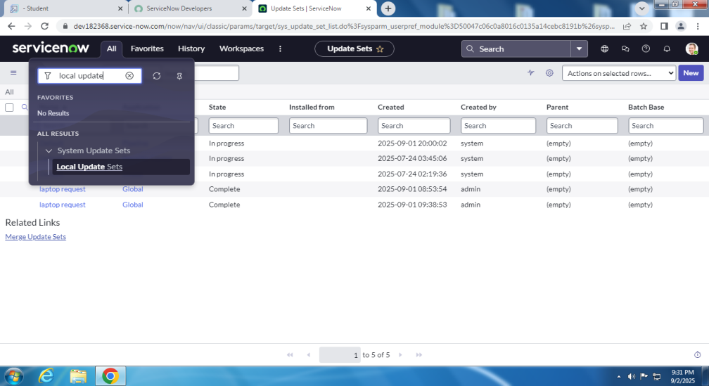

**Create Service Catalog Item**

1. Click on All >> service catalog(maintain items)

Fill the required details and create it.

2. add variables in it.

**Create Catalog Ui Policies**

In catalog ui policies,create a catalog item.

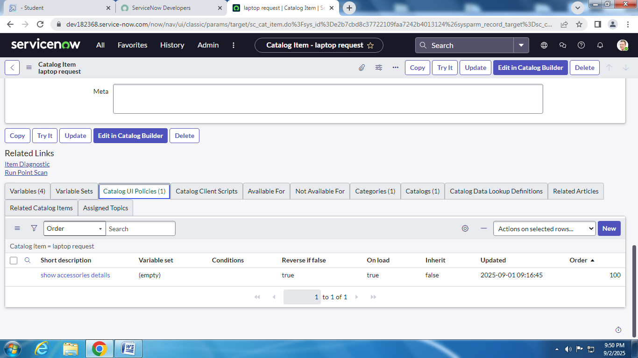

**Create Ui Action**

1.all>>ui actions.

2.create a new ui actions with required details.

**Exporting Changes To Another Instances**

1.all>>local update set>>laptop request>>need to change complete.

2.Export xml>>download the file.

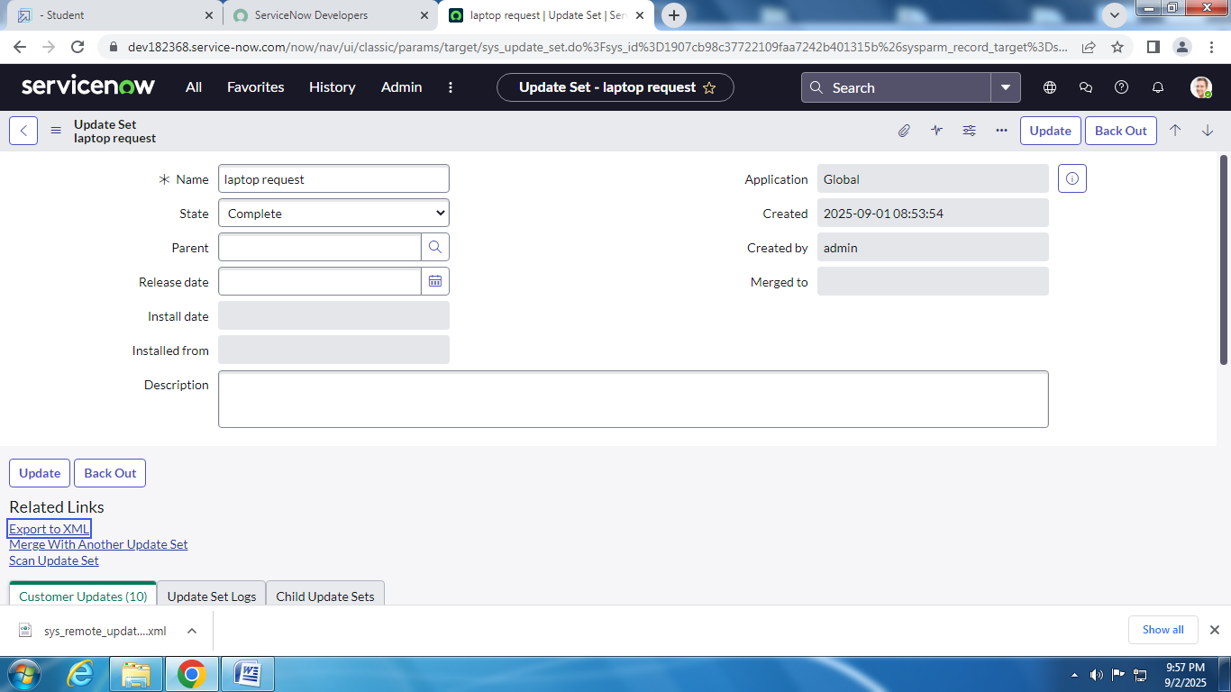

**Retrieving The Update Set**

Open another instance in another browers and import the xml file in it.

Click on the commited update set.

**Test Catalog Item**

Atlast laptop request catalog item is created and it is tested.

Final result is viewed in service catalog>>hardware>>laptop request.

**Conclusion :**

The Laptop Request Catalog Items project provides a structured and efficient way to manage laptop requests within an organization. By creating a centralized catalog, users can easily view available options, place requests, and track their status in a streamlined manner.Overall, the project enhances user convenience, supports effective IT resource management, and contributes to better organizational productivity.